

{hadoop HDFS assignment}

[BIG DATA ,LINUX COMMANDS]



Submitted by:

Puranjay Kwatra

24th March

TEKSYSTEMS

**Big Data (HDFS) Assignment**

Problem Statement: Using Command line of HDFS, perform following tasks.

1. Create a directory /hadoop/hdfs/ in HDFS

hdfs dfs -mkdir /user/Hadoop/hdfs/Puranjay_dir

hdfs dfs -ls /user/Hadoop/hdfs/

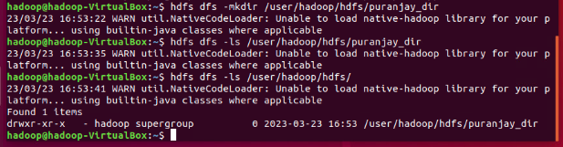

1. Create a temp directory in Hadoop. Run HDFS command to delete “temp” directory.

Hdfs dfs -rm -r /user/Hadoop/temp

Hdfs dfs -ls /user/hadoop

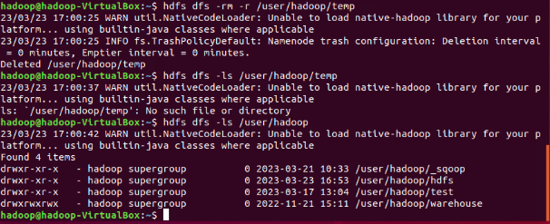

1. List all the files/directories for the given hdfs destination path.

Hdfs dfs -ls /user/Hadoop/hdfs

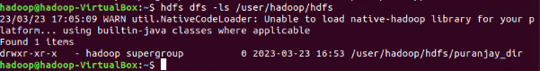

1. Command that will list the directories in /hadoop folder.

Hdfs dfs -ls /user/hadoop

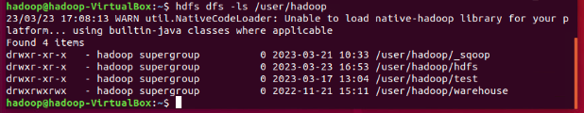

1. Command to list recursively all files in hadoop directory and all subdirectories in hadoop directory

Hdfs dfs -ls -R /user/hadoop

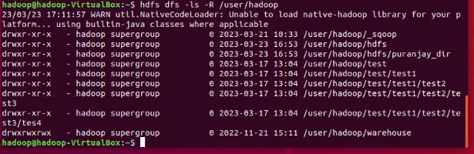

1. List all the files inside /hadoop/hdfs/ directory which starts with 'dir'.

Hdfs dfs -ls /hadoop |grep dir

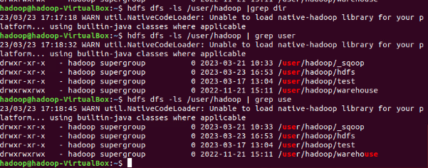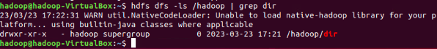

1. Create a temp.txt file. Copies this file from local file system to HDFS

Hdfs dfs -copyFromLocal temp.txt .hadoop.dir

Nano /hdfs/dir

Nano /hdfs/dir/temp.txt

Hdfs dfs -ls /Hadoop/dir

Hdfs dfs -cat /Hadoop/dir/temp.txt

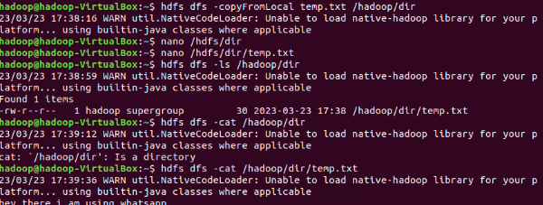

1. Copies the file from HDFS to local file system.

Hdfs dfs -copyToLocal /Hadoop/temp1.txt /

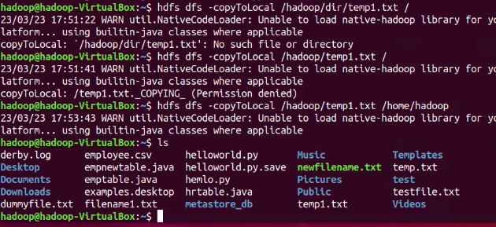

1. Command to copy from local directory with the source being restricted to a local file reference.

Hdfs dfs -put temp.txt /hadoop

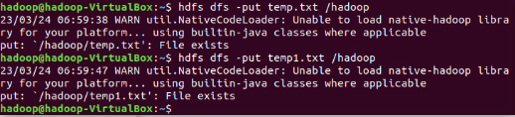

1. Command to copies to local directory with the source being restricted to a local file reference.

Hdfs dfs -get /Hadoop/tempo.txt

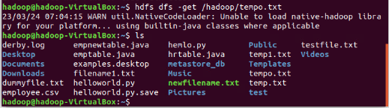

1. Command to move from local directory source to Hadoop directory.

Hdfs dfs -put -f temp1.txt /hadoop

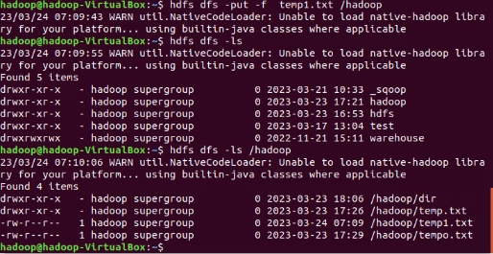

1. Deletes the directory and any content under it recursively.

Hdfs dfs -rm -r /Hadoop/dir

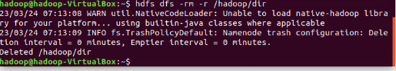

1. List the files and show Format file sizes in a human-readable fashion.

Hdfs dfs -ls -h /hadoop

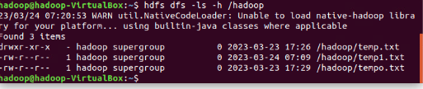

1. Take a source file and outputs the file in text format on the terminal.

Hdfs dfs -text /Hadoop/temp.txt

Hdfs dfs -cat /Hadoop/tempo.txt

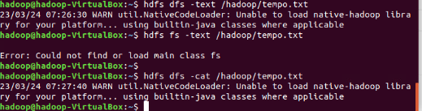

1. Display the content of the HDFS file test on your /user/hadoop2 directory.

Hdfs dfs -put /home/Hadoop/tempo.txt /user/Hadoop/test

Hdfs dfs -cat /user/Hadoop/test/tempo.txt

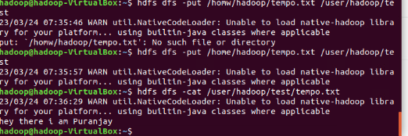

1. Append the content of a local file test1 to a hdfs file test2.

Hdfs dfs -appendToFile /home/Hadoop/temp.txt /user/Hadoop/test/tempo.txt

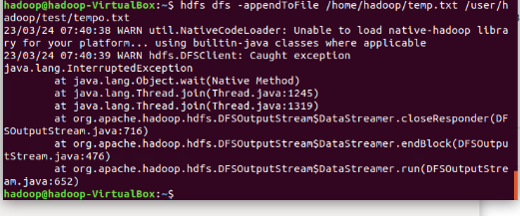

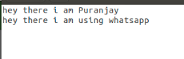

1. Show the capacity, free and used space of the filesystem

Hdfs dfs -df /

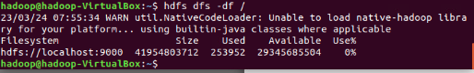

1. Shows the capacity, free and used space of the filesystem. Add parameter Formats the sizes of files in a human-readable fashion.

hdfs -df -h /

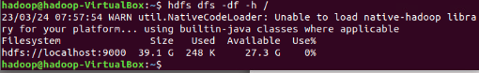

1. Show the amount of space, in bytes, used by the files that match the specified file pattern.

Hdfs dfs -du /user/Hadoop/h*

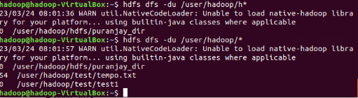

1. Show the amount of space, in bytes, used by the files that match the specified file pattern. Formats the sizes of files in a human-readable fashion.

Hdfs dfs -du -h /user/*

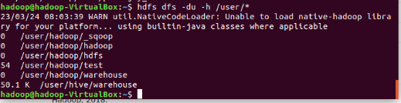

1. Check the health of the Hadoop file system.

Hdfs fsck

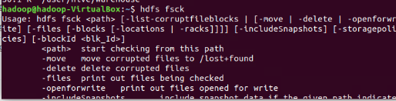

1. Command to turn off the safemode of Name Node.

Hdfs dfsadmin -safemode leave

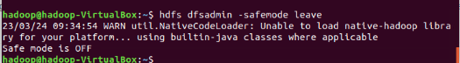

1. HDFS command to format NameNode.

hdfs namenode -format

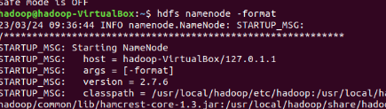

1. Create a file named hdfstest.txt and change it number of replications to 3.

Hdfs dfs -touchz /user/Hadoop/hdfstest.txt

Hdfs dfs -setrep -R 3 /user/Hadoop/hdfstest.txt

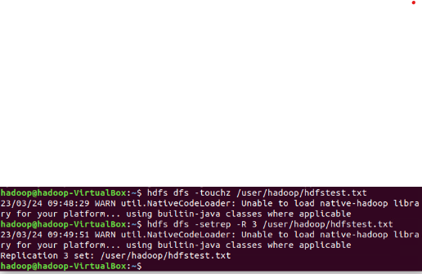

1. Write command to display number of replicas for hdfstest.txt file.

Hdfs fsck /user/Hadoop/pk.txt -files -blocks -racks

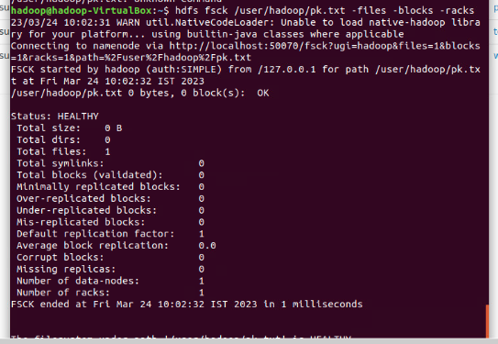

1. Write command to Display the status of file “hdfstest.txt” like block size, filesize in bytes.

hdfs dfs -stat “%o %s” /user/Hadoop/hdfstest.txt

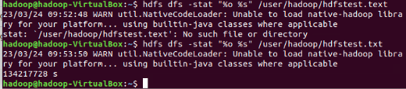

1. Write HDFS command to change file permission from   
    rw – r – r to rwx-rw-x for hdfstest.txt.

Hdfs dfs -chmod 775 /user/Hadoop/hdfstest.txt

Hdfs dfs -ls /user/hadoop

